LAB221Assignment | Type: | Short Assignment
 | Code: | J2.S.P0115
 | LOC: | 50
 | Slot(s): | 1

Title
Verify input data
Background Context
NA

Program Specifications
Use swing library to create a program to verify input data.
Information should be verified:
- Student code: max length is 10, not contains special characters (@, #, $)
- Student name: max length is 30
- Birth Date: in format MM/DD/YYYY
- Phone number: max length is 15, contain numeric characters only (0 – 9)
- Email: max length is 30, contain only one “@” character, do not contain special characters (!, #, $)

Function details:

NA
Expectation of User interface:
The screen should be as:

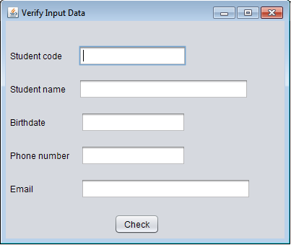

Guidelines

